22.May.2023
To,
Drug Controller General of India
Directorate General of Health and Family Welfare,
Government of India,
FDA Bhawan, ITO,
Kotla Road, New Delhi-110002

Sub: Justification of Quantity Proposed to Be Manufactured.

We {manufacturerName}, {manufacturerAddress} do hereby confirm that we have applied for {numberofKits} for manufacturing which will be used as follows:

Test Per Kit = 100 test
Total Test Proposed = 100 kits (10,000 tests) for a total of three lots.
Therefore, for One lot approximately 3,300 tests (33 kits required).

Total Kit manufactured/ Lot = | No. of Kits
Utilization Break up of Kit Manufactured
QC Testing, Verification and Validation | {numberofKits}
Accelerated Stability Study | {numberofKits}
In Use Stability Study | {numberofKits}
Shipping Stability Study | {numberofKits}
Performance Evaluation at External lab | {numberofKits}
Real Time Stability Study | {numberofKits}
Retained Samples | {numberofKits}
Total Kits | {totalKits}

Note:

Thanking you
Yours truly,
{manufacturerName}

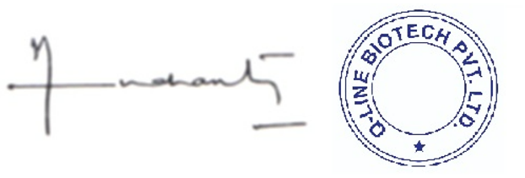
{directorName}
Director

